Problem 1 output:
Mean: 5.29468
Median: 5.239
Standard Deviation: 2.113102
Interquartile range: 2.61725
30th percentile: 3.96925

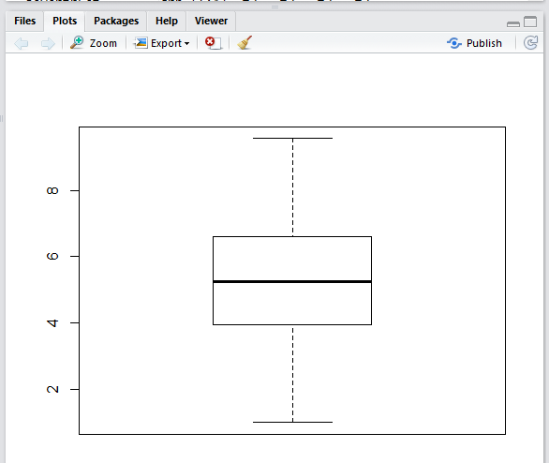

Problem 2 output:
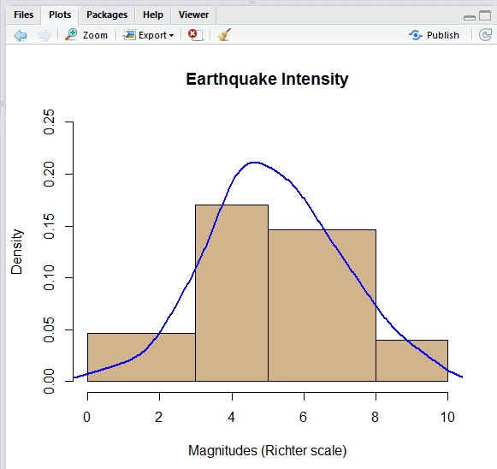
Problem 3 Output:
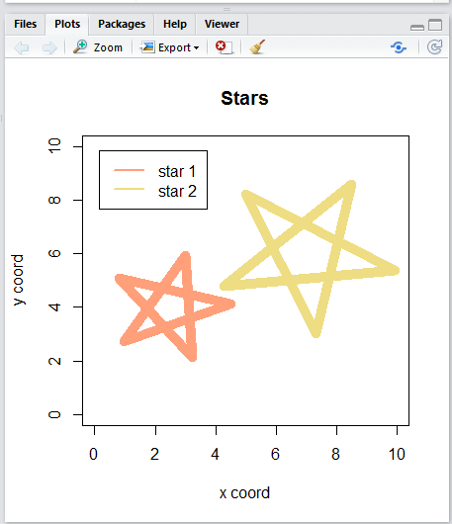

Problem 4 Output:
See stars.pdf

